Handon-11 Event Example app

Info: Double clicking on the .js files you can able to see the content



Src/SayWelcome.js

// src/SayWelcome.js

import React from 'react';

const SayWelcome = () => {

  const greet = (message) => {

    alert(`Message: ${message}`);

  };

  return (

    <div>

      <button onClick={() => greet('Welcome')}>Say Welcome</button>

    </div>

  );

};

export default SayWelcome;

Welcome Output:

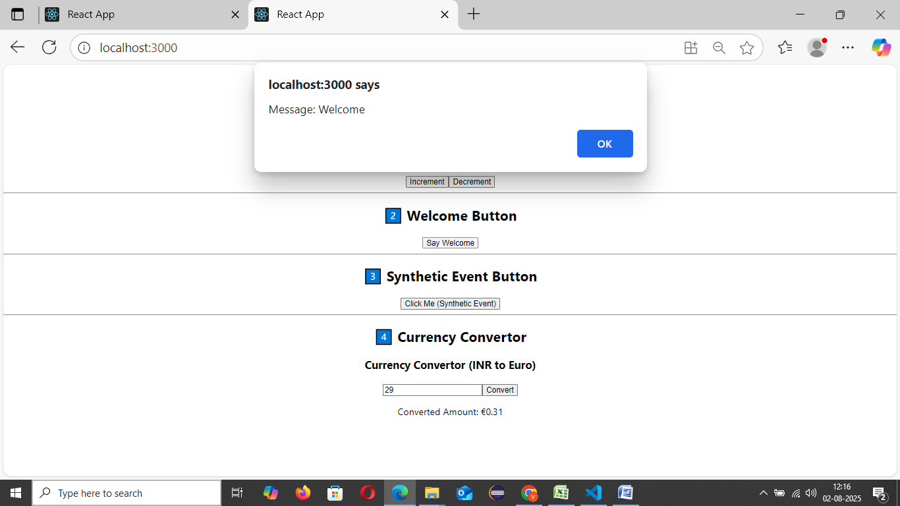

Src/Counter.js

import React, { Component } from 'react';

class Counter extends Component {

  constructor() {

    super();

    this.state = {

      count: 0

    };

  }

  // Method to show alert message

  sayHello = () => {

    alert("Hello, Member");

  };

  // Method to increment and call sayHello

  handleIncrement = () => {

    this.setState({ count: this.state.count + 1 });

    this.sayHello();

  };

  // Method to decrement

  handleDecrement = () => {

    this.setState({ count: this.state.count - 1 });

  };

  render() {

    return (

      <div>

        <h2>Counter Value: {this.state.count}</h2>

        <button onClick={this.handleIncrement}>Increment</button>

        <button onClick={this.handleDecrement}>Decrement</button>

      </div>

    );

  }

}

export default Counter;

Output

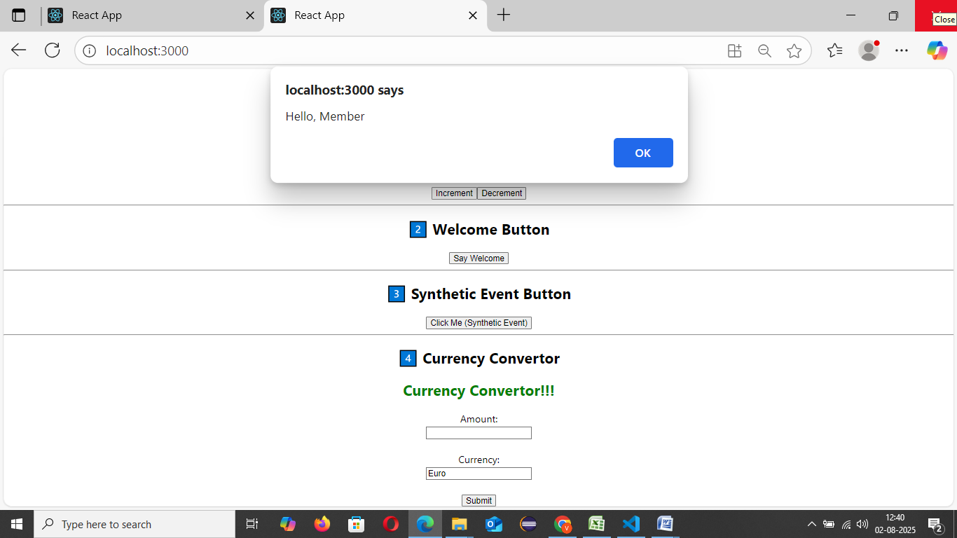

Src/SyntheticEventExample.js

// src/SyntheticEventExample.js

import React from 'react';

const SyntheticEventExample = () => {

  const handleClick = (e) => {

    e.preventDefault();

    alert("I was clicked");

  };

  return (

    <div>

      <button onClick={handleClick}>Click Me (Synthetic Event)</button>

    </div>

  );

};

export default SyntheticEventExample;

Output

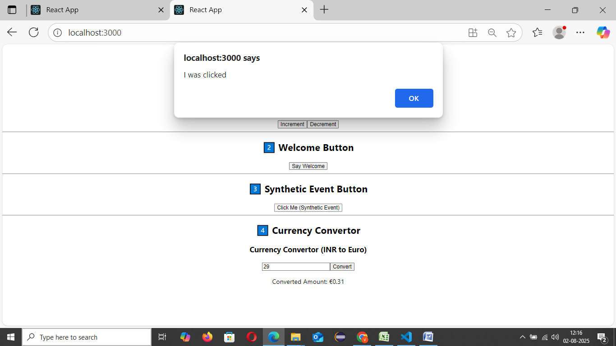

CurrencyConverter.js

// src/CurrencyConvertor.js

import React, { useState } from 'react';

const CurrencyConvertor = () => {

  const [amount, setAmount] = useState('');

  const handleSubmit = (e) => {

    e.preventDefault();

    // Convert INR to Euro (1 Euro = ₹80 assumed here)

    const euro = parseFloat(amount) / 0.0125; // Or: amount \* 80

    alert(`Converting to Euro Amount is ₹${Math.round(euro)}`);

  };

  return (

    <div>

      <h2 style={{ color: 'green' }}>Currency Convertor!!!</h2>

      <form onSubmit={handleSubmit}>

        <label>Amount:</label><br />

        <input

          type="number"

          value={amount}

          onChange={(e) => setAmount(e.target.value)}

        /><br /><br />

        <label>Currency:</label><br />

        <input type="text" value="Euro" readOnly /><br /><br />

        <button type="submit">Submit</button>

      </form>

    </div>

  );

};

export default CurrencyConvertor;

Output

